AI Generative Test Design

Requirements & Acceptance Criteria

Test Plan

Table of Contents

Table of Contents

1. Project Details 2

2. Features Under Test 3

3. Background 3

4. Epic Description 3

5. Application Features 3

6. User Stories 3

7. Requirements Via Images 4

8. Sitemap / Wireframes 5

9. Additional Documents 5

10. Document Information 5

**Project Details**

|  |  |
| --- | --- |
| **Client Name** | Alliant Group |
| **Project Name** | SES |
| **Application Name** | TIMS & TIMS Admin |
| **Domain** | Insurance |

# **Features Under Test**

* 1. **Enrollment**
  + Policy
  + Premium
  1. **Underwriting**
* Underwriting
* Premium

# **Background**

The client has requested the development of a Self-Service Enrollment Portal to process online enrollment requests and applications

# **Epic Description**

The Enrollment Portal is a self-service platform designed to facilitate online enrollment requests. This portal will cater to both applicants and agents, allowing them to submit applications and process enrollment requests efficiently.

# **Application Features**

Agent/Applicant Information

Medicare Information

Payment Gateway

Application Submission and Confirmation

# **User Stories**

**# 1 About Enrollment Page**

**Description:**

As an Applicant/Authorized Representative, I need access to the Enrollment Portal, specifically the About Enrollment page, once I have selected a specific plan in the Application UI. This enables me to initiate my enrollment request.

**Acceptance Criteria:**

**Criterion 1:**

Plan Name, Year, PBP #, and Plan description should be automatically filled based on the plan and contract # selected in the UI.

**Criterion 2:**

FAQs should be displayed on this page to guide me through my enrollment request:

"Who can use this form?

People with Medicare who want to join a Medicare Advantage Plan or Medicare Prescription Drug Plan.

**# 2 Applicant Information Page**

**Description:**

As an Applicant/Broker/Authorized Representative, I need access to the Applicant Information page after clicking "Next" from the About Enrollment page. This allows me to input demographic and personal information for myself or the applicant.

**Acceptance Criteria:**

**Criterion 1:**

I should be able to enter the applicant's First Name with a maximum of 50 characters. This field is mandatory, and if left blank, an error message "First name is required" should appear. Special characters (e.g., !@#$%^&*) are not allowed.

**Criterion 2:**

The applicant's Middle Initial can be entered with a maximum of 1 character. This field is optional. Special characters are not allowed.

# **Requirements Via Images**

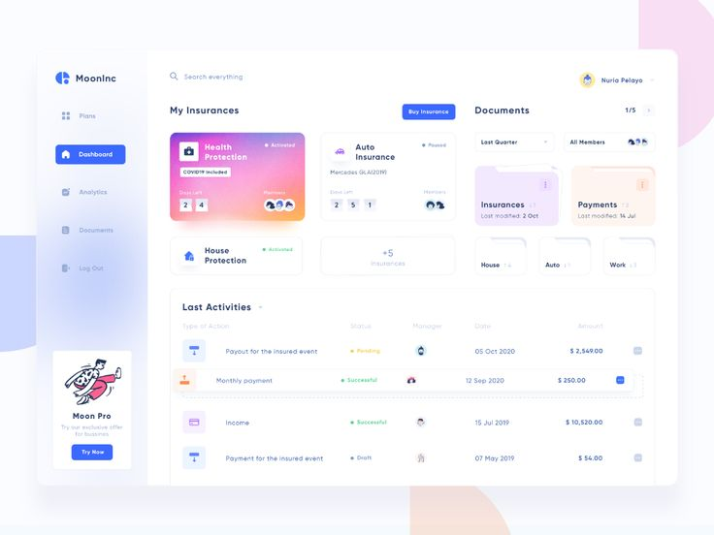

# **Sitemap / Wireframes**

Attach here

# **Additional Documents**

BRD, FSD, Scope documentation if any. Please attach here.

# **Document Information**

|  |  |  |  |  |
| --- | --- | --- | --- | --- |
| **Version** | **Date** | **Change** | **Prepared By** | **Approved By** |
| V1.0 | 17th Oct 2024 | Draft Version | Dhanalakshmi M | Nisha A Sangamithra |